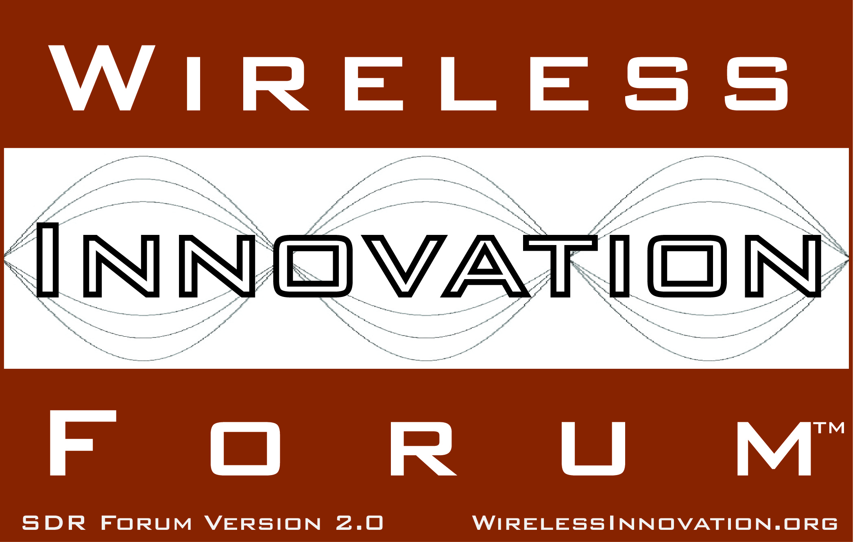
Project for Enabling Context Aware Cognitive Radio Announced by Wireless Innovation Forum
Identifies mechanisms for cognitive radios to identify and reason over operating context; simplifies the application of Big Data to RF problems (Big RF)
For Immediate Release
Washington, DC – 14 August 2013 – The Wireless Innovation Forum (www.WirelessInnovation.org), a non-profit international industry association dedicated to driving the future of radio communications and systems worldwide, today announced approval of a project to develop mechanisms to enable a cognitive radio to classify its operational and message context, leverage information from the application layer and online databases, and better reason on the meaning and content of data. The project, Information Process Architecture (IPA) v3: Context Aware Cognitive Radio, is led by James Neel and Peter Cook of Cognitive Radio Technologies.

“This is an exciting project as an understanding of and exploitation of context is critical to making cognitive radios “cognitive” and will allow cognitive radio applications to grow beyond DSA to include personalizing your network experience, automating and simplifying dynamic network configuration, and improving spectral efficiency by automatically adapting network design to the situation at hand,” said Neel.

The third Information Process Architecture (IPA) project builds on the two previous IPA products (http://groups.winnforum.org/d/do/5689 and http://groups.winnforum.org/d/do/3546) to provide a series of documents that describe a) how an information system can represent contextual information, b) how to identify and classify operational and message context, and c) applications to public safety disaster responses, enhanced smartphones, enterprise wireless networks, smart grid management, and spectrum monitoring.

The Forum encourages participation from organizations wanting to be involved in this important project. Please contact Forum CEO Lee Pucker at Lee.Pucker@WirelessInnovation.org if you are interested.

Wireless Innovation Forum member representatives have initiated and led multiple work efforts that promote their organization’s specific objectives through the creation of reports, recommendations and specifications that are widely used by the advanced wireless community. The importance of these "work products" is reflected in the fact that over 12,000 individual documents were downloaded from the document library in 2012 alone.

# # #
About the Wireless Innovation Forum
Established in 1996, The Wireless Innovation Forum (SDR Forum Version 2.0) is a non-profit mutual benefit corporation dedicated to driving technology innovation in commercial, civil, and defense communications worldwide. Members bring a broad base of experience in Software Defined Radio (SDR), Cognitive Radio(CR) and Dynamic Spectrum Access (DSA) technologies in diverse markets and at all levels of the wireless value chain to address emerging wireless communications requirements. To learn more about The Wireless Innovation Forum, its meetings and membership benefits, visit www.WirelessInnovation.org.

Editorial Contacts
Lee Pucker, 604-828-9876, Lee.Pucker@wirelessinnovation.org or
Stephanie Hamill, 970-290-9543 or Stephanie.Hamill@wirelessinnovation.org

